**RDBMS Basic Info**

DBMS Vs Database

-- Lot of people refer to database as DBMS (Database Management System).

-- But that is not entirely correct.

-- A database is just a container that stores data whereas DBMS is a software which is used to manage your database. You need DBMS to interact with the database, to store, modify, store and protect data.

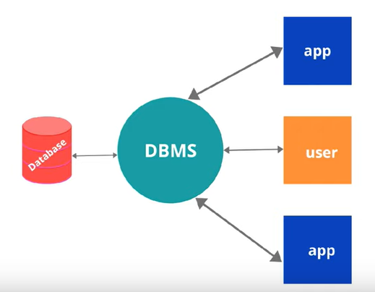

-- DBMS is also required to create, modify, and delete database.

Evolution Of Database

-- Evolution of database is started in 1960s.

-- The first type of database which was made of the ‘Flat File Database.’ Here the data was stored in simple file such as CSV files or fixed lengths file(txt).

-- Later, came the Hierarchical database and then the network database.

-- Both databases used to store the data parent-child relationship but these databases were incapable of storing complex data relationships. That is the reason they are soon replaced by relational database.

-- In today’s world, there are two popular databases – 1. Relational database, 2. Non-Relational database.

-- As per the usage, over 74% databases that are in use are relational database.

-- However, the tech giants who must store the data of millions of users everyday are using combination of both.

-- Oracle is the most widely used relational database.

-- MongoDB is the most widely used non-relational database.

Relational Database

-- In a relational database, data is stored through collection of tables.

-- These tables are connected to each other.

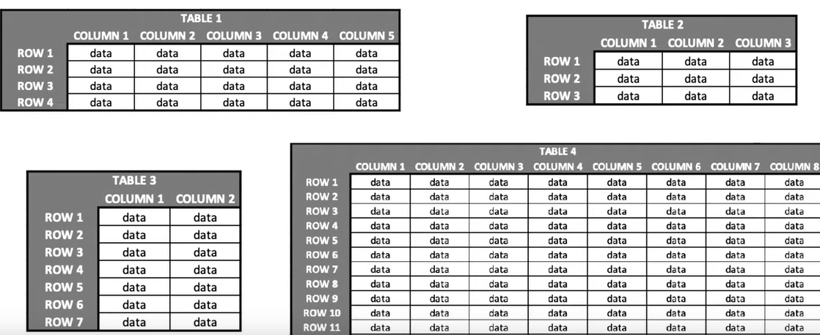

-- Each table consists of columns and rows.

-- Each column has a name and its datatype.

-- A datatype can be called as ‘Data Rule’ which is associated with each column. Only those data which satisfies this data rule can be inserted into the specific column.

-- A row can be treated as a record formed by single or multiple columns.

-- Let us take an example of office database.

-- It will have information related to Employees, Managers and Departments.

-- These details are stored in different tables. But these tables will be related to each other through certain columns.

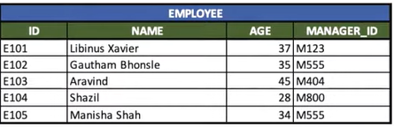

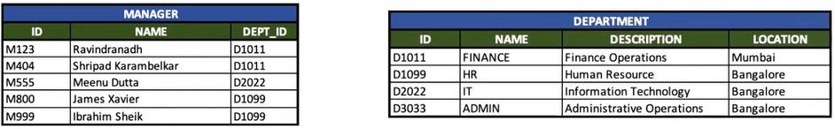

-- Here employee and manager tables are related to each other through manager_id column which is common in both the tables.

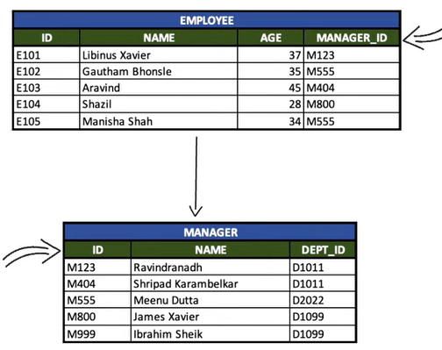

-- In a relational database, foreign key constraint is used to form relations between the different tables.

-- Similarly, manager and department tables are related to each using department id column.

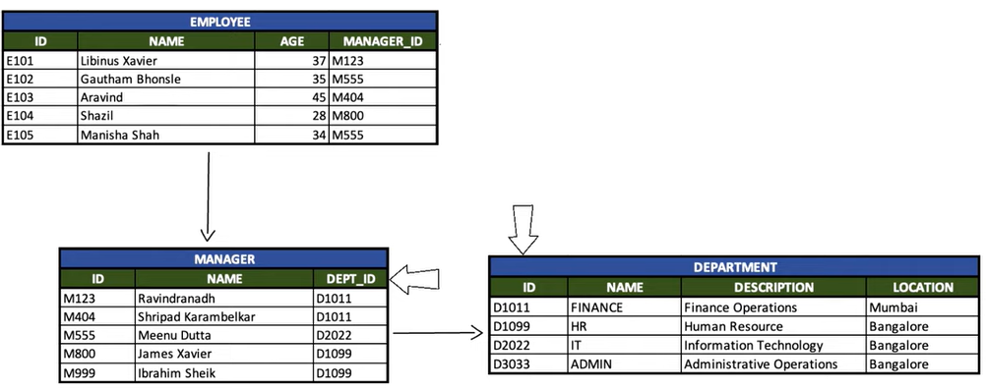

-- Here Employee and Department tables are not directly related to each other. But still it is possible to fetch data from the employee table based of specific conditions from the department table.

-- This is how relational database works.

-- Information is scattered across multiple tables related to one another. And using table relations, it is possible to retrieve the data from different tables.

-- In a relational database, using DBMS (Database Management System), you can enter commands in specific language to store, retrieve and modify data in specific language i.e., SQL (Structured Query Language).

-- This is how relational database works.

Schema

-- What is schema in PostgreSQL?

> Schema is a collection of logical structures of data. In PostgreSQL, schema is a named collection of tables, views, functions, constraints, indexes, sequences etc.

> PostgreSQL supports having multiple schemas in a single database.

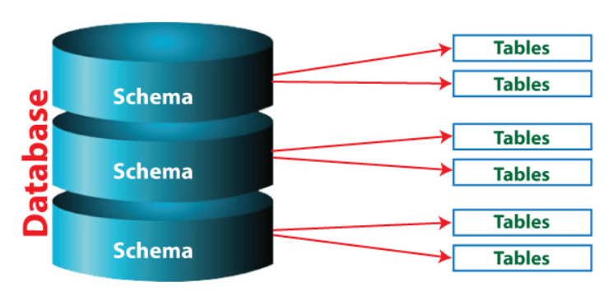

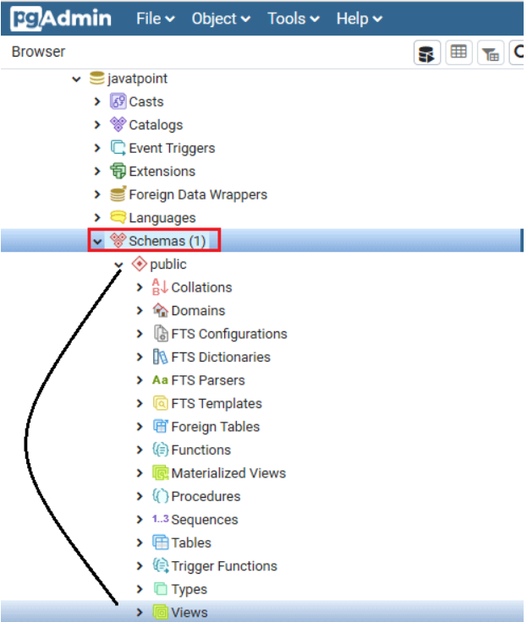

-- Why do we need to use schemas in PostgreSQL?

> The end-users can use only those schemas that allows the separation of test tables and logic from production tables.

> We can quickly restore the data, which is present in the distinct schema. Thus, the application-oriented schemas can be individually returned and backed up for recovery and time travel.

> When the application data is in the schema, we can manage the application changes. Therefore, a new version of the application can work on the table structure in a new schema, including a simple modification to the schema name.

-- current_schema() method is used to returned the currently used schema.

> SELECT current_schema();

-- We can use CREATE SCHEMA command for creating the schema.

-- We can use DROP SCHEMA command for dropping the schema.

-- We can use ALTER SCHEMA command for renaming/modifying the schema.

DBMS (Database Management System)

> Interaction with Database (Store word Nahi.)

RDBMS (Relational Database Management System)

> Why Relational DBMS? ----- The way of interaction > SQL.

Non-RDBMS (Non- Relational Database Management System)

> Why Non-relational DBMS? – The way of interaction > NoSQL

DB (Database)

> PostgreSQL, PgAdmin

> Container that stores data (interaction word Nahi.)

RDB (Relational Database)

> Why Relational DB? – The way of storage > Tables.

Non-RDB (Non-Relational Database)

> Why Non-Relational DB – The way of storage > Other than tables. (Key-value pairs, file systems, wide columns, graphs etc.)